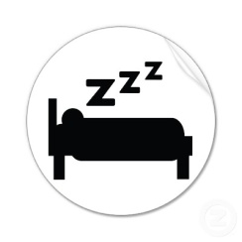 SLEEP LOG: Total Hours slept in 1 week: __________
DATE
Bed Time
Wake Time
# of Times woken up during the night
What did you do before bed? Ex. Phone, TV, Workout.etc.
Caffeine during day? When? How much?
Exercise? What? How long?
Meals per day? Fast Food?

How much water?
TOTAL # of Hours Slept

