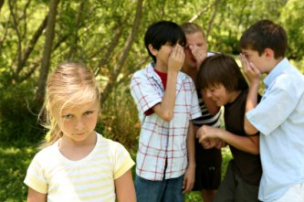
Peer Pressure

Definition: _________________________________________________________

NEGATIVE | POSITIVE

So how do people have so much influence on us?!!! How do they do that?!! It’s called…. __________________________
- Threats

- Blackmail

- Mocking/Teasing

- Guilt Trips

- Bargaining

- Flattery

- Bribing
______________________________________________________________________________________
Assertive Refusal

1)

2)

3)

